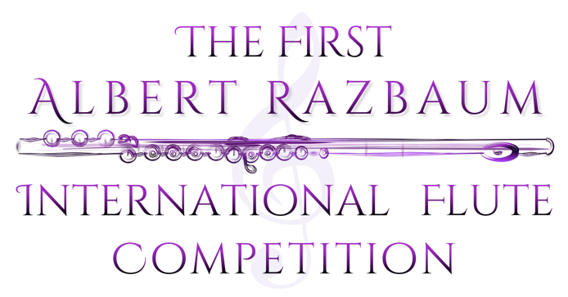

REGLAMENT

Of the 1st Albert Razbaum International Flute Competition
September 2020
MOSCOW

CONDITIONS
- The competition will be held at Alexander Skriabin museum (Bolshoy Nikolopeskovskiy pereulok, 11)
Winners Concert will be held in Zaryadie Concert Hall with Novaya Rossiya Symphony orchestra.
Flautists aged from 16 to 32 are invited to take part in the competition.
Deadline for applications July 10, 2020.
The following papers should be attached to the application form:
- copy of the passport or valid ID - proof of the registration fee payment
- 2 recommendation letters written by two well-known musicians - one good quality photo (.jpg)
All the documents are to be sent to the following address: competitionmfc@gmail.com
Applications sent after the deadline (July 10) will not be considered.
Accommodation and living costs of the participants and their pianists during the competition are at the responsibility of the participants.
Registration fee is: 70 Euros.
The amount (Registration fee) should be paid in full to the Moscow Flute Center
Account (click “Registration fee” at www.magicflutecenter.com) by July 10,2020
In case of cancellation by the participation, the registration fee will not be refunded.
For the participants chosen for live audition the registration fee is: 35 Euros.
Registration fee is to be paid by August 20, 2020
Due to the pandemic we can accept applications with an the piano backing track supplied by Razbaum Competition. Please contact us at competitionmfc@gmail.com

Programme:

Preliminary round (video)
Gabriel Faure​ ​ ​- «Fantasie» op.79 for flute and piano

First round (Live audition)

1) Georg Philipp​ Telemann​ ​ - «Fantasia» for solo flute /one from 12 to be chosen/
2) Edison Denisov​ - «Prelude and Aria» for Flute and Piano
3) Philippe Gaubert - «Nocturne et Allegro Scherzando» for Flute

Second round (Live audition)
1) to choose​ one of the following :
a. Theobald Boehm - «Fantasy sur des air eccossaise» op.25
b. Anatoli Samonov - «Sonata» for Flute and Piano
2) W. A. Mozart - «Sonata» k304 (any edition or arrangement)
3) Yuko Uebayashi - «Sonata» for Flute and Piano, movements​ 2 and 3

JURY MEMBERS
Ulla Miilmann
Philippe Jundt
Silvia Careddu
Denis Lupachev
Irina Stachinskaya

COMPETITION REGULATIONS
The preliminary round consists of video auditions. The deadline for applications and recordings is July 10, 2020
No more than 15 participants will be selected for the final round.
The order of performer will be decided by a draw at the opening ceremony and will be kept for the rest of the competition. All participants are expected to attend the opening ceremony which will be held in September (the exact date will be announced )
The order of the pieces can chosen by the participants.

PRIZES

1 prize - 150000 rubles
2 prize - 100000 rubles
3 prize - 50000 rubles

All finalists will receive diplomas. Jury members can award special prizes for best performances of required pieces.

Agreement
For processing of personal data_______________________________passport no __________________________________

Issued_________________________________________________________________________
(By whom, where)
According to the articles of 3 and 9 of the Federal Law of 27 July 2006 no. 152-FZ con personal data" I give my permission to use my personal details within the 1st Albert Razbaum International Flute Competition 2020
This agreement is valid for one year.
This agreement can be cancelled by written application.

" " ____________2020__ г. | __________________
Signature

